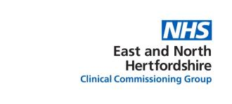

My Care Record
Answers to your questions

What is My Care Record?

My Care Record is a new system which means that health and care professionals can see your health records while they are treating you.

So another doctor can quickly see information about you from your local doctor (GP).

They can only do this if you have given your permission.

It means that every health and care professional has the information to make the best decisions about your health.

Why has My Care Record been created?
People told us that they wanted health services to be more joined-up.
Joined-up means that they work better together.

My Care Record will help health services to work better together.

How do they use My Care Record?
Health professionals will see your health records using a computer system.

They can only see your records. They cannot copy, save or change your records. However, if you agree to see a GP as part of the ‘extended access’ service then details of your consultation will be included in your health record.

What information will be seen?
They will be able to see all of your health records.
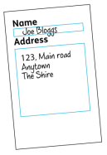
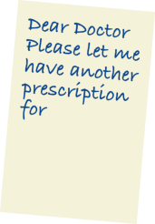
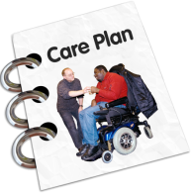
This includes:
- your name, address, NHS Number and phone number
- your medication
- results of any tests
- copies of any letters
- what has happened in the past
- emergency department treatment
- your appointments
- your health plans
- mental health issues
- social care lead co-ordinator and your care plan

Who can see my record?

Only health and care professionals who are involved in your care can see your records.
They need your permission before they can see it.

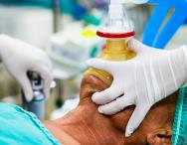
If there is an emergency they may be able to see your record without your permission.
The system keeps a note of everyone who has seen your record.

What is the benefit for me?
- health and care professionals will work together better to give you the best health care
- doctors can work quicker
- there is less paperwork
- you won’t be asked the same questions so often
- you may need less tests

Who is leading My Care Record?

My Care Record involves many NHS and social care organisations.

To start with only staff at Princess Alexandra Hospital Trust have been using My Care Record.

It is being introduced to other hospitals but is also being used to share records as part of the GP ‘extended access’ service.

Can I choose whether to give permission?
Yes. You can opt out of My Care record.

Opting out will mean that it will take doctors longer to work out the best way to help you.

If you want to opt out you should speak with your local doctor (GP).

They will ask you to complete a form.

If you opt out you can change your mind at any time.

If you want to share only part of your records you need to talk with your own local doctor (GP).

Who can add things to My Care Record?
If any comments need to be made they will be added to the local record and attached to My Care Record the next time it is viewed.

Is my information safe?
Your information can only be seen over a secure computer system.
The law says that all people working in health and social care must respect your privacy and keep all information about you safe.

You should be told when people are looking at your records.

This might not be possible in an emergency.

Can I see My Care Record?

You can ask to look at any information that is being held about you. This includes information on a computer system.

You should ask your local doctor, or any of the health professionals that are treating you.

Can my carer decide for me?
Your carer can only decide if they have the legal power to make decisions for you. This is usually through a power of attorney.

Is My Care Record separate from other computer systems?
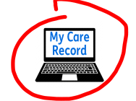
The NHS has other computer systems
which collect information for other reasons.
They are not linked to My Care Record in any way.

Is social care information included in My Care Record?
My Care Record may contain some of your social care information.

In the future we want to include all your social care information so we can give you a joined-up service.

Will it affect my benefits?
No.

My Care Record will only be used by professionals involved with your care.

Can the government see My Care Record?
No. My Care Record can only be seen by local health and care professionals.

Will the record include treatment outside the local area?

No. My Care Record only includes information from local health and care organisations.

Will you share my information with research or insurance companies?

No. Your personal information will not be shared or sold to any private organisations including research or insurance companies.

How to make a complaint

If you want to make a complaint about My Care Record please:
speak with your local doctor (GP)
call: 01992 566 140
web: www.mycarerecord.org.uk

For more information
If you need more information please contact us on:

Tel: 01992 566 140
Email: weccg.comms@nhs.net

